Main use cases ERD Diagram

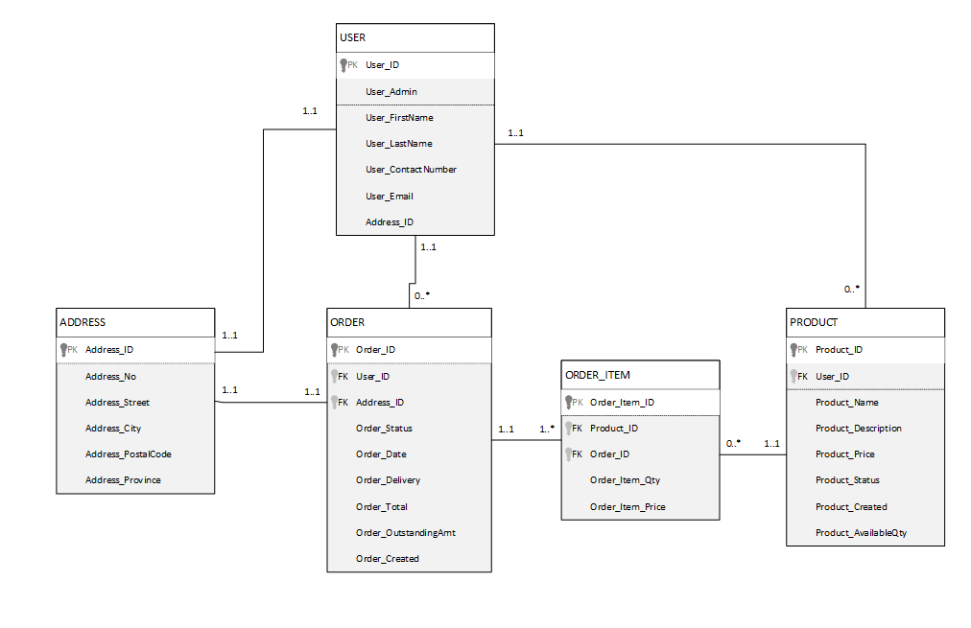

**Sequence diagrams**

Update Product Availability Sequence diagram



Create Account Sequence Diagram

Customer

Create Product/Meal Sequence diagram



Manager

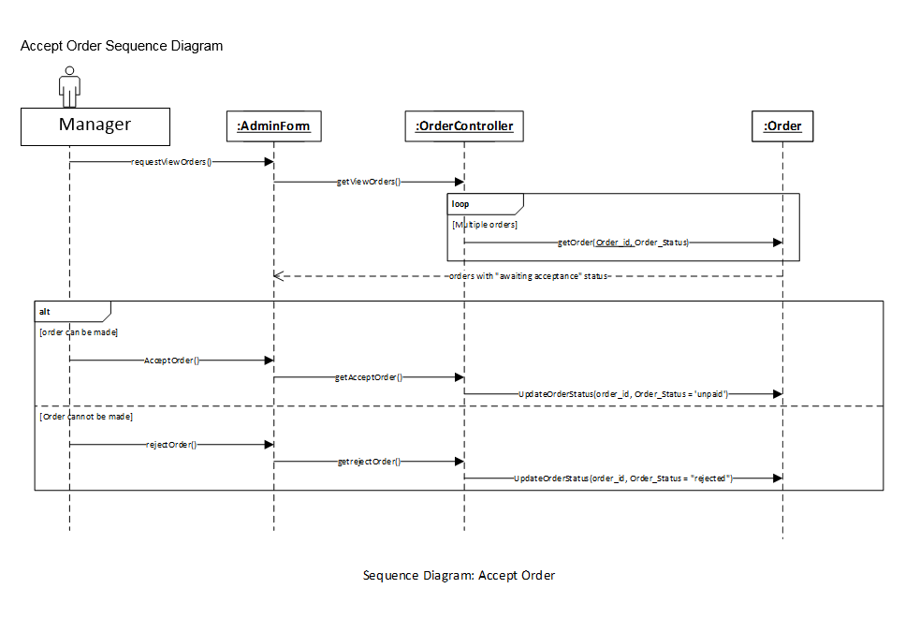Accept Order Sequence Diagram

Manager

Place Order Sequence diagram

State machine diagram: Order_Status

State machine diagram: Product_Status

